|  |
| --- |
|  |
| Implementation Procedure |
| **Customization of Requisition Form** |
|  |
| **March 2023** |
|  |

**Implementation Procedure**: Customization of Requisition Form

## This implementation procedure applies to the following change request:

|  |  |
| --- | --- |
| CR No | Title |
| **2020/CRQ/CON/ERP/FND/XXX** | Customization of Requisition Form |

### Primary Audience

* ITD IOMD SSO
* ITD QCMD RMO
* ITD AMD ISSA

1. Login to ERP as System Administrator
2. Navigate to System Administrator 🡪 Security 🡪 Responsibility 🡪 Define
3. Create New Responsibilities (Appendix A)
4. Customize Requisition Form (Appendix B)
5. Assign responsibility to relevant users

# Appendices

## Appendix A

* Log in to ERP as System Administrator
* Navigate to System Administrator 🡪 Security 🡪 Responsibility 🡪 Define
* Create new responsibility as seen below:

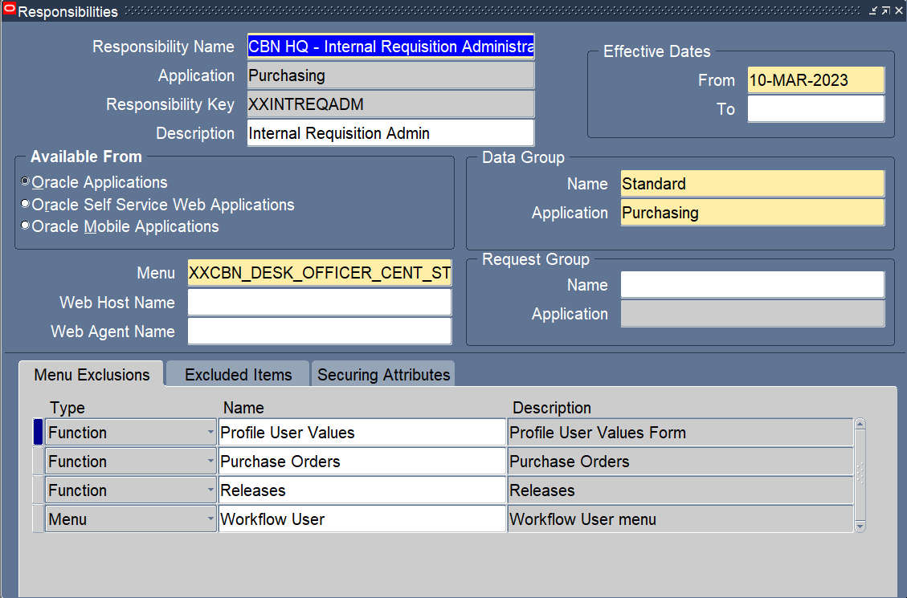

|  |  |  |
| --- | --- | --- |
| S/N | Field | Value |
|  | Responsibility Name | CBN HQ - Internal Requisition Administrator |
|  | Application | Purchasing |
|  | Responsibility key | XXINTREQADM |
|  | Description | Internal Requisition Admin |
|  | Menu | XXCBN_DESK_OFFICER_CENT_STORE |
| Data Group | | |
|  | Name | Standard |
|  | Application | Purchasing |
| Menu Exclusions | | |
|  | Functions | Profile User Values |
|  | Functions | Purchase Orders |
|  | Functions | Releases |
|  | Menu | Workflow User |

## Appendix B

*Prerequisites*

*Ensure the following system profile values are configured as detailed below at user level:*

|  |  |  |  |
| --- | --- | --- | --- |
| S/N | Profile Option Name | Profile Value | Profile Level |
|  | FND: Diagnostics | Yes | User |
|  | Hide Diagnostics menu entry | No | User |
|  | Utilities:Diagnostics | Yes | User |

* Log in to ERP as Purchasing Super User
* Navigate to Purchasing Super User 🡪 Requisitions 🡪 Requisitions

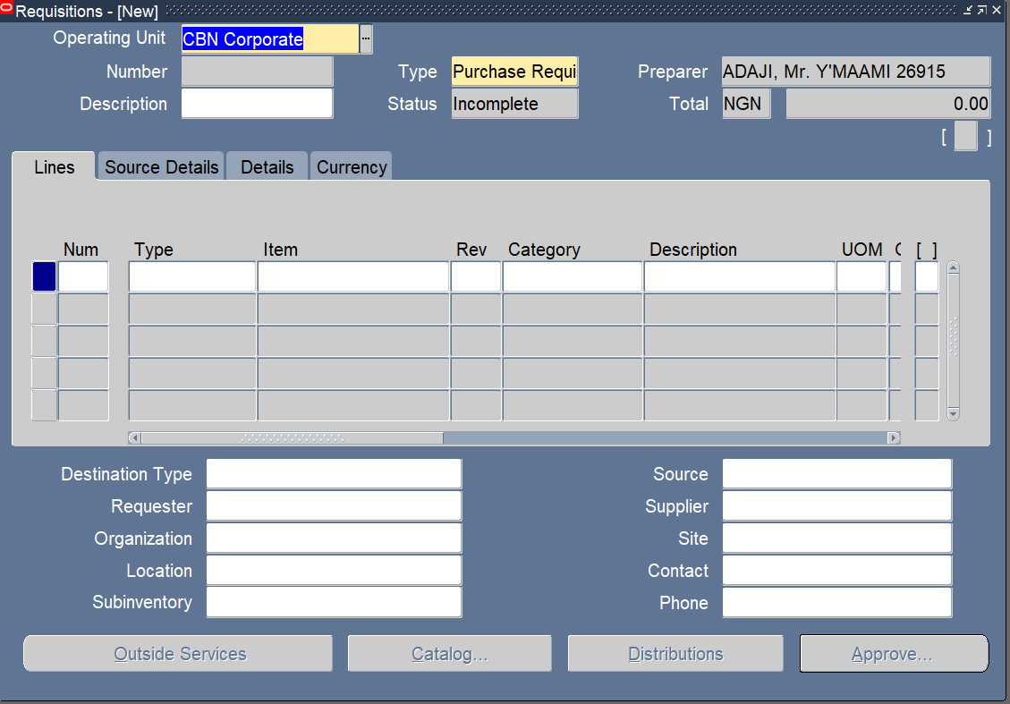

* + From the toolbar, navigate to Help 🡪 Diagnostics 🡪 Custom Code 🡪 Personalize

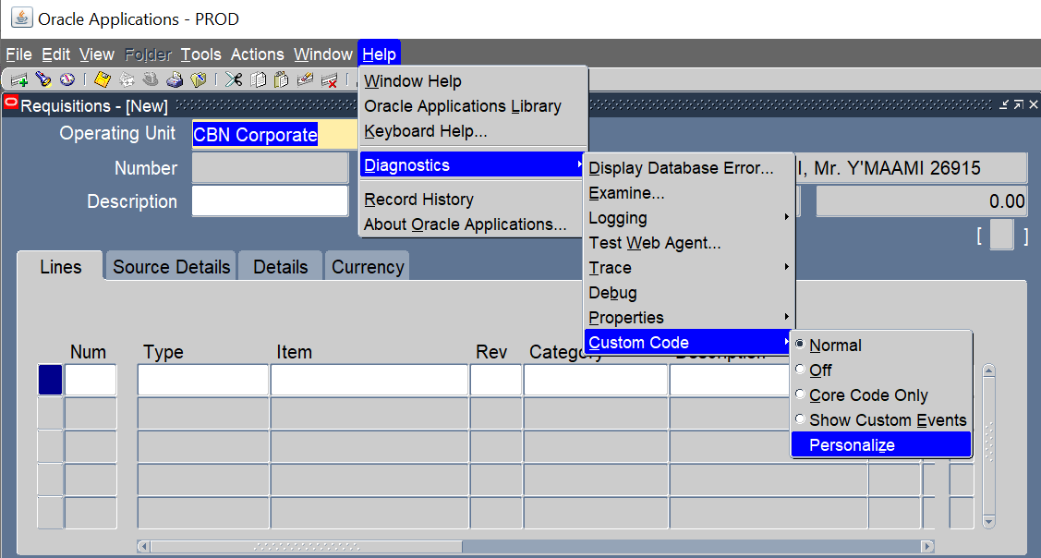

* + Apply personalization as seen below:
    - Disable requisition type field

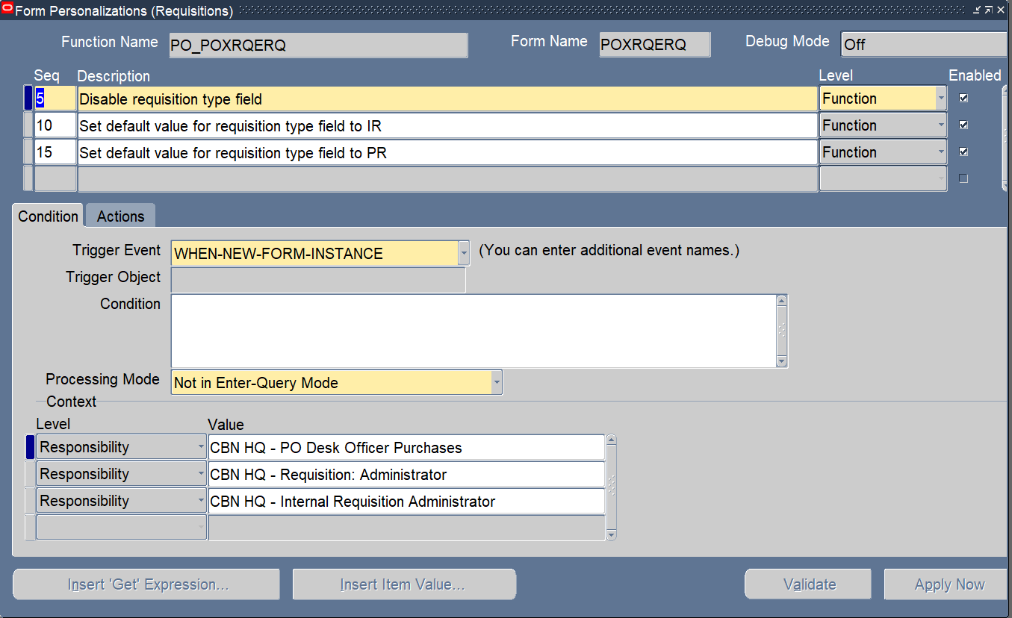

|  |  |  |
| --- | --- | --- |
| S/N | Name | Value |
|  | Trigger Event | WHEN-NEW-FORM-INSTANCE |
|  | Processing Mode | Not in Enter-Query Mode |
| Context | | |
|  | Responsibility | CBN HQ - PO Desk Officer Purchases |
|  | Responsibility | CBN HQ - Requisition: Administrator |
|  | Responsibility | CBN HQ - Internal Requisition Administrator |

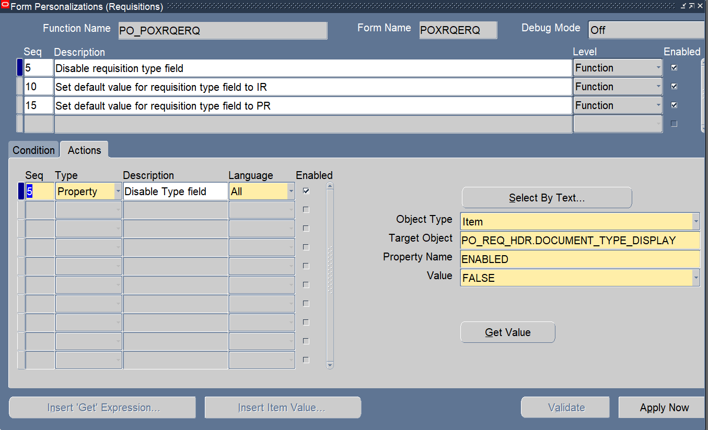

|  |  |  |
| --- | --- | --- |
| S/N | Name | Value |
|  | Object Type | Item |
|  | Target Object | PO_REQ_HDR.DOCUMENT_TYPE_DISPLAY |
|  | Property Name | ENABLED |
|  | Value | FALSE |
| Seq | Type| Description | Language | | |
|  | Property | Disable Type field |

* Set default value for requisition type field to IR

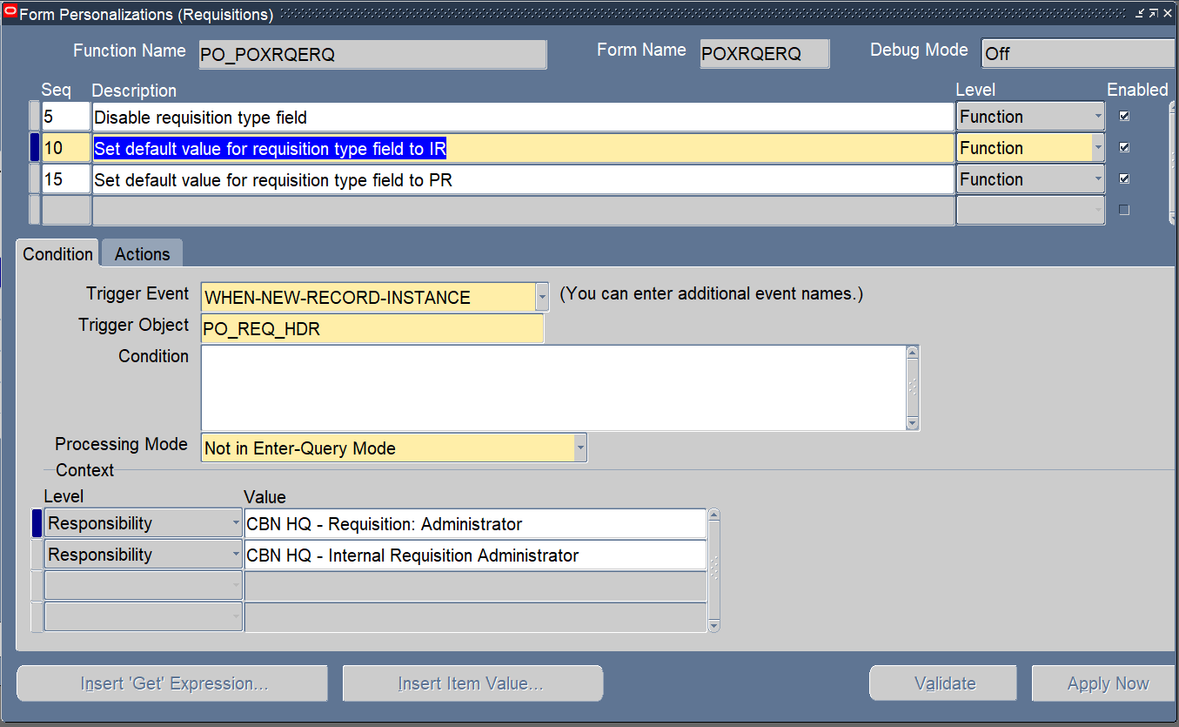

|  |  |  |
| --- | --- | --- |
| S/N | Name | Value |
|  | Trigger Event | WHEN-NEW-RECORD-INSTANCE |
|  | Trigger Object | PO_REQ_HDR |
|  | Processing Mode | Not in Enter-Query Mode |
| Context | | |
|  | Responsibility | CBN HQ - Requisition: Administrator |
|  | Responsibility | CBN HQ - Internal Requisition Administrator |

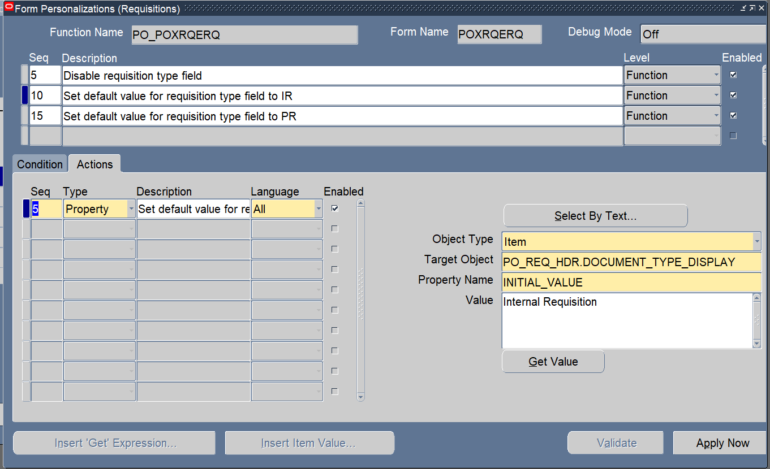

|  |  |  |
| --- | --- | --- |
| S/N | Name | Value |
|  | Object Type | Item |
|  | Target Object | PO_REQ_HDR.DOCUMENT_TYPE_DISPLAY |
|  | Property Name | INITIAL_VALUE |
|  | Value | Internal Requisition |
| Seq | Type| Description | Language | | |
|  | Property | Set default value for requisition type field to IR |

* Set default value for requisition type field to PR

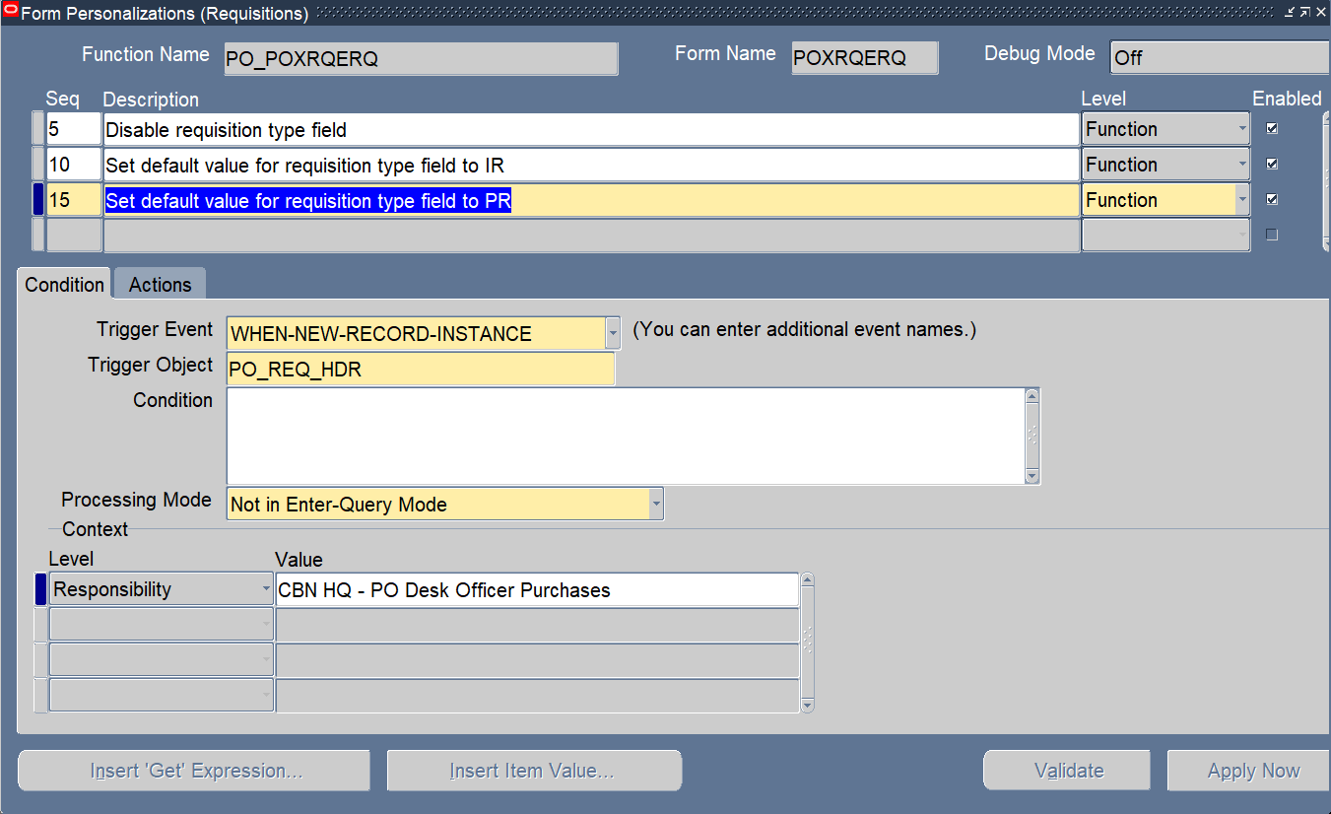

|  |  |  |
| --- | --- | --- |
| S/N | Name | Value |
|  | Trigger Event | WHEN-NEW-RECORD-INSTANCE |
|  | Trigger Object | PO_REQ_HDR |
|  | Processing Mode | Not in Enter-Query Mode |
| Context | | |
|  | Responsibility | CBN HQ - PO Desk Officer Purchases |

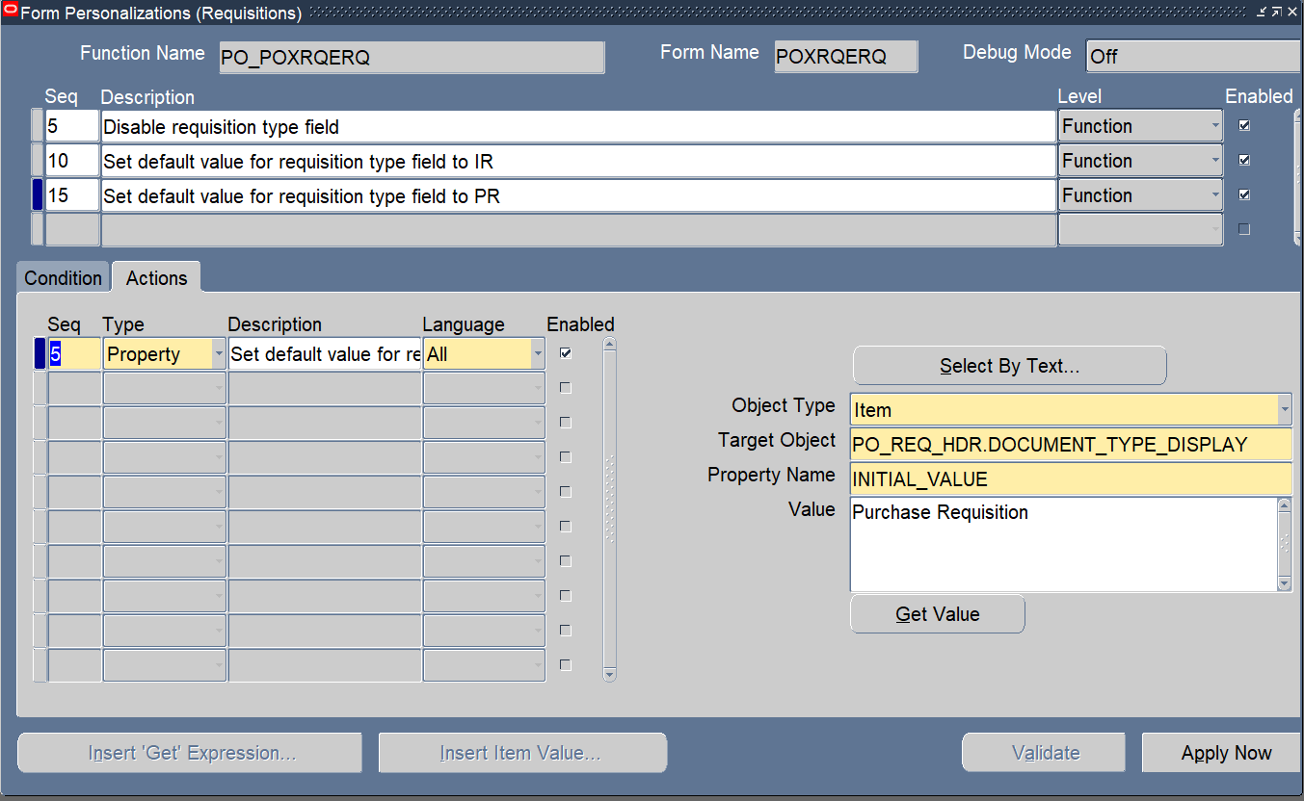

|  |  |  |
| --- | --- | --- |
| S/N | Name | Value |
|  | Object Type | Item |
|  | Target Object | PO_REQ_HDR.DOCUMENT_TYPE_DISPLAY |
|  | Property Name | INITIAL_VALUE |
|  | Value | Purchase Requisition |
| Seq | Type| Description | Language | | |
|  | Property | Set default value for requisition type field to PR |

|  |
| --- |
|  |
| Implementation Procedure |
| **Request to Modify Additional Qualification** |
|  |
| **April 2023** |
|  |

**Implementation Procedure**: Request to Automate Additional Qualification

## This implementation procedure applies to the following change request:

|  |  |
| --- | --- |
| CR No | Title |
| **2022/CRQ/CON/ERP/FND/XXX** | Request to Automate Additional Qualification |

### Primary Audience

* ITD IOMD SSO
* ITD QCMD RMO
* ITD AMD ISSA

1. Login to ERP with **Approvals Management Business Analyst** responsibility (Appendix A)
2. Create a new Attribute (Appendix B)
3. Create two conditions (Appendix C)
4. Create Approver Group (Appendix D)
5. Create a new action type (Appendix E)
6. Create a new rule (Appendix F)

# Appendices

## Appendix A

* Log in to Oracle ERP Production environment with **Approvals Management Business Analyst** responsibility.
* Navigate to **Approvals Management Business Analyst -> Business Analyst Dashboard**

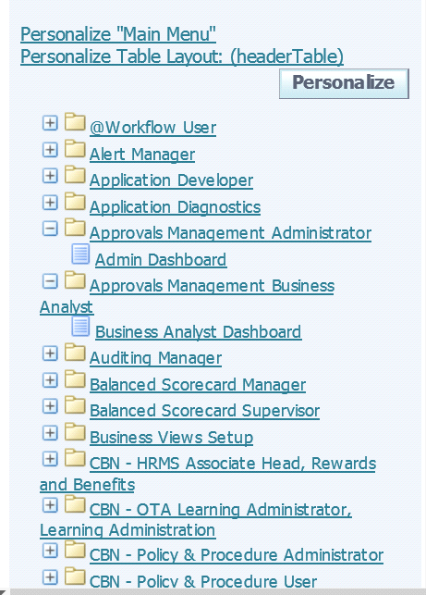

* Navigate to **Oracle Self Service Human Resources** and click the icon on the **setup** column

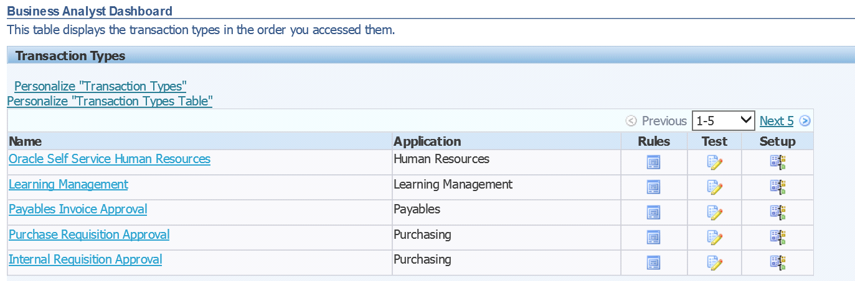

## Appendix B (Create new Attributes)

* Click on the **create** buttonto create a new attribute

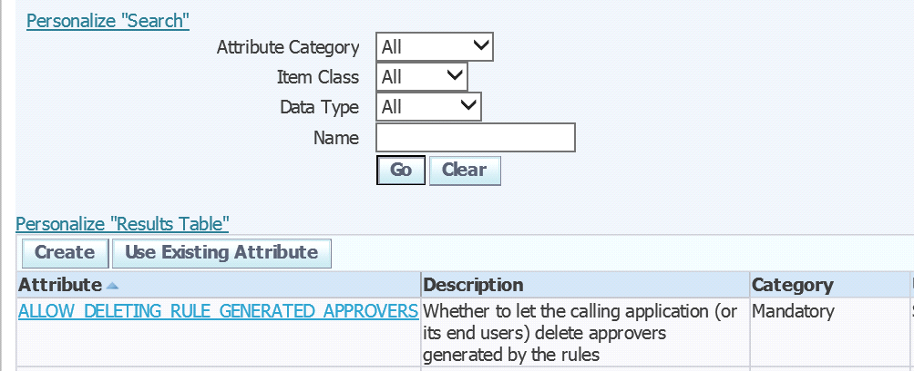

* Create **QUALIFICATION_STATUS** as seen below then copy and paste the query below under the **value** text area and click on **Apply.**

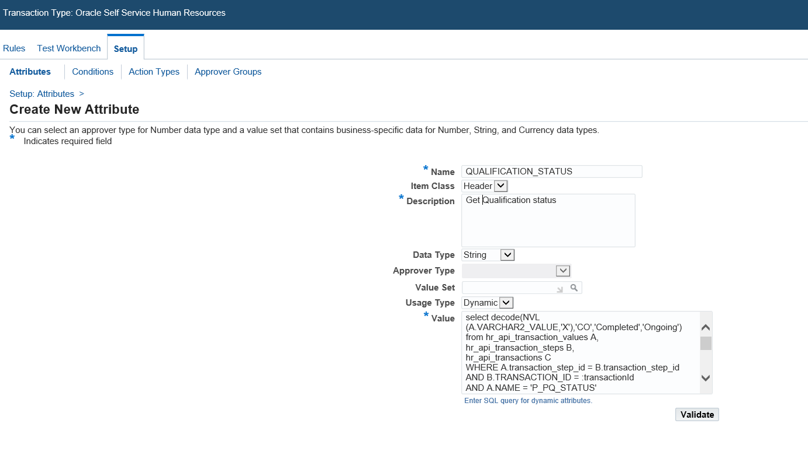

select decode(NVL

(A.VARCHAR2_VALUE,'X'),'CO','Completed','Ongoing')

from hr_api_transaction_values A, hr_api_transaction_steps B, hr_api_transactions C

WHERE A.transaction_step_id = B.transaction_step_id

AND B.TRANSACTION_ID = :transactionId

AND A.NAME = 'P_PQ_STATUS'

and b.transaction_id = c.transaction_id

AND c.process_name in ('HR_QUALIFICATION_JSP_PRC', 'HR_AWARD_JSP_PRC')

UNION

select 'Not Applicable' from hr_api_transactions

where process_name not in ('HR_QUALIFICATION_JSP_PRC', 'HR_AWARD_JSP_PRC')

AND TRANSACTION_ID = :transactionId

## Appendix C (Create new Conditions)

* Navigate to condition. Click the create button to create two new conditions on the **QUALIFICATION_STATUS** attribute with string values
* **Completed**
* **Ongoing**

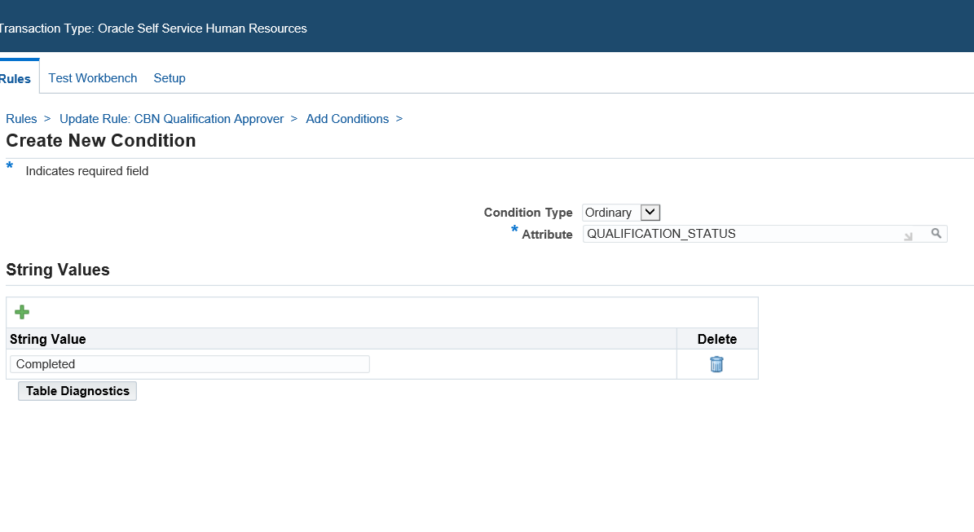

* Then Click on Apply

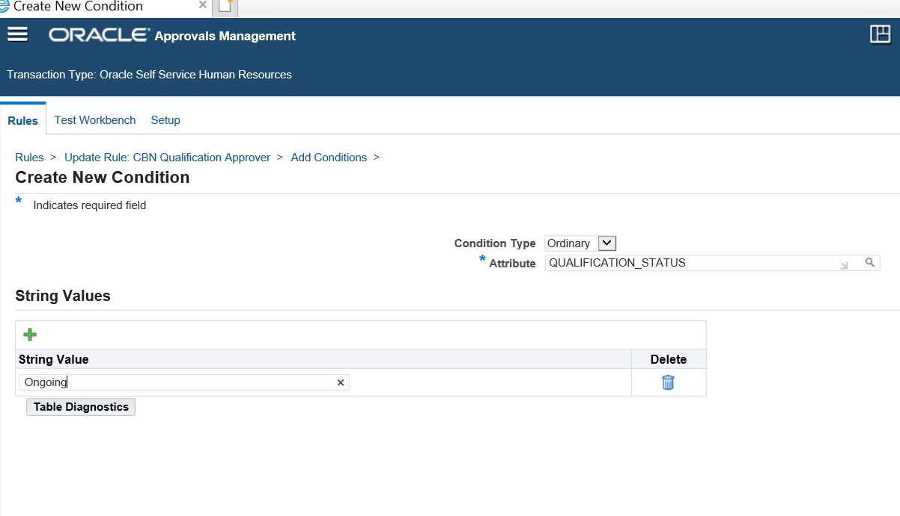

* Then Click on Apply

## Appendix D (Creating Approver Group)

* Navigate to **Approver** **Group**
* Click **create** button to create Approver Group **CBN HR Service Centre Approval Group**

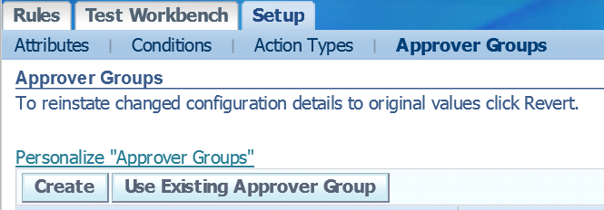

* In the **query** text area, enter the following query and click the **validate** button to validate the query then click app

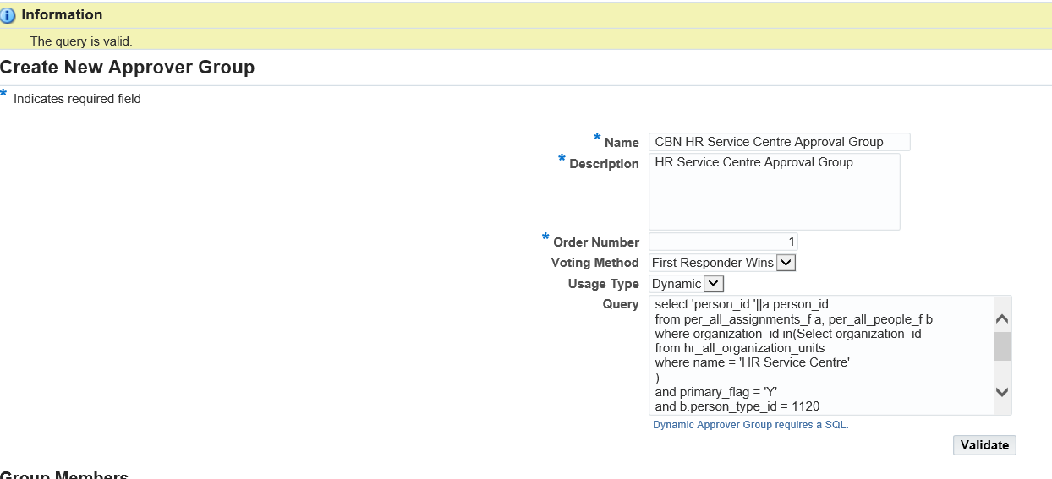

select 'person_id:'||a.person_id

from per_all_assignments_f a, per_all_people_f b

where organization_id in(

Select organization_id

from hr_all_organization_units

where name = ' HR Help Desk'

)

and primary_flag = 'Y'

and b.person_type_id = 1120

and a.person_id = b.person_id

and sysdate between a.effective_start_date and a.effective_end_date

and sysdate between b.effective_start_date and b.effective_end_date

**Then click on Apply**

## Appendix E (Creating Action Type)

* Create a new action type **first-responder-parallel**
* Navigate to Setup Tab 🡪 Action types Tab
* Click on **Use Existing Action Type**
* Click on **Create**

|  |  |  |
| --- | --- | --- |
| S/N | Field | Value |
| 1 | Name | first-responder-parallel |
| 2 | Handler | ame_ag_chain_handler |
| 3 | Rule type | Chain of authority |
| 4 | Description | First responder parallel |
| 5 | Allowed Approver type | As seen on the image below |
| 6 | Dynamic | User Entered |

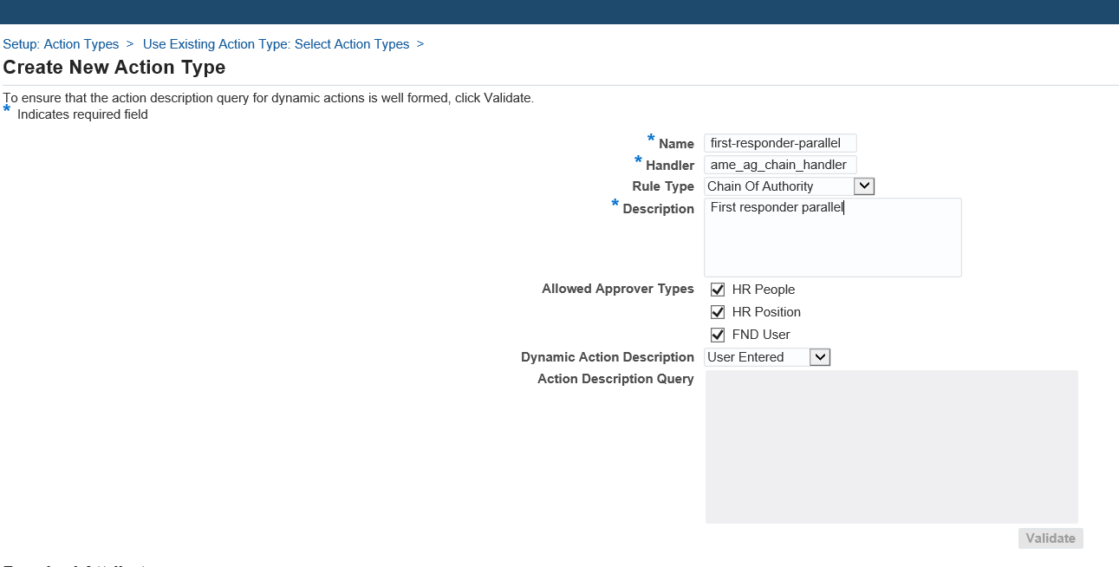

* Click add button and
* add ALLOW_EMPTY _APPROVAL GROUPS

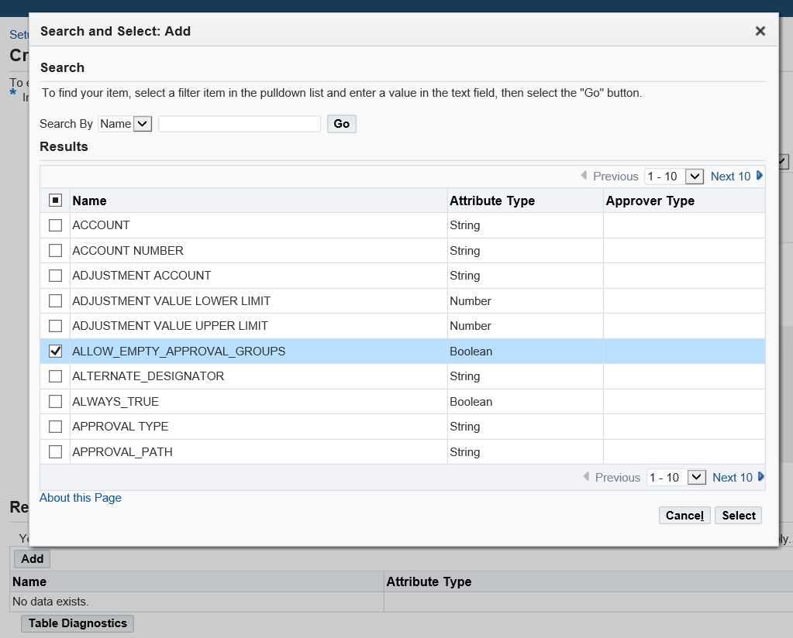

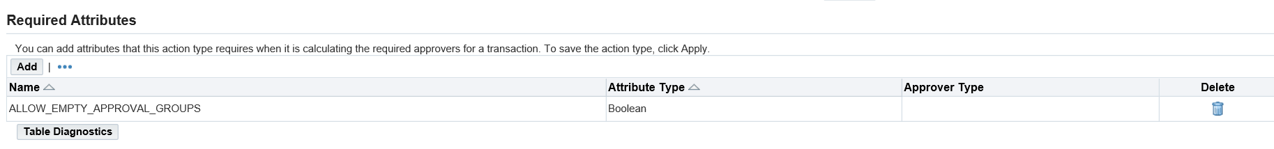

* Click apply, then click continue
* Go to action type select “first-responder-parallel”
* Change the voting method to “First Responder Wins”,
* Ordering mode to ‘Parallel’ and order number ‘1’

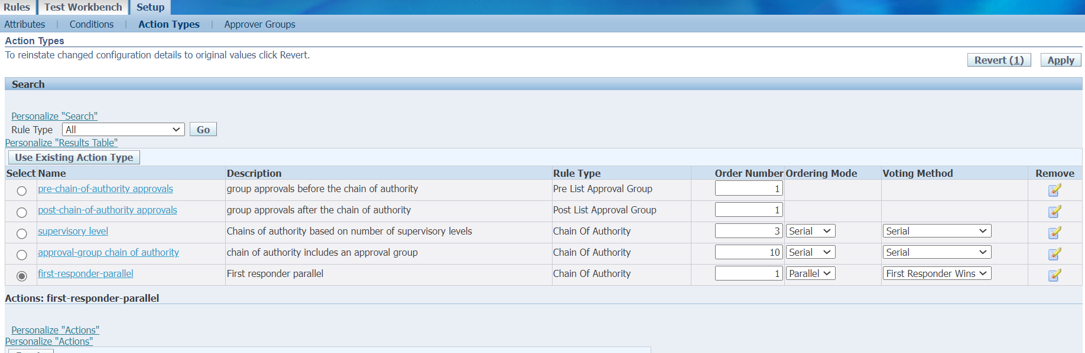

* Click apply
* Select newly created action type, then click on **Add** **Action**

Create a new action as seen below:

|  |  |  |
| --- | --- | --- |
| S/N | Field | Value |
| 1. | Description | Require approval from CBN HR Service Centre Approval Group |
| 2. | Parameter One | *<Run script below on database to get* ***approval_group_id*** *value for parameter one>* |

Script for parameter one:

*Select approval_group_id,name from AME_APPROVAL_GROUPS where name = '****CBN HR Service Centre Approval Group****';*

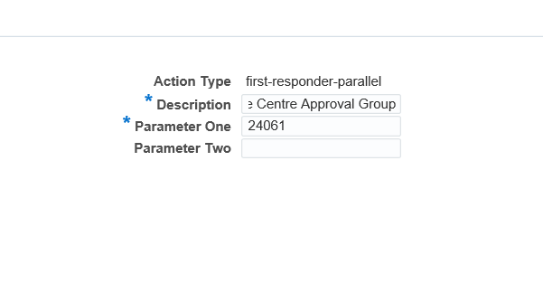

* Click apply

## Appendix F (Creating Rule)

* Navigate to **rules** and click on the **create** button to create a new rule and click next.
* **CBN Completed Qualification Approval**

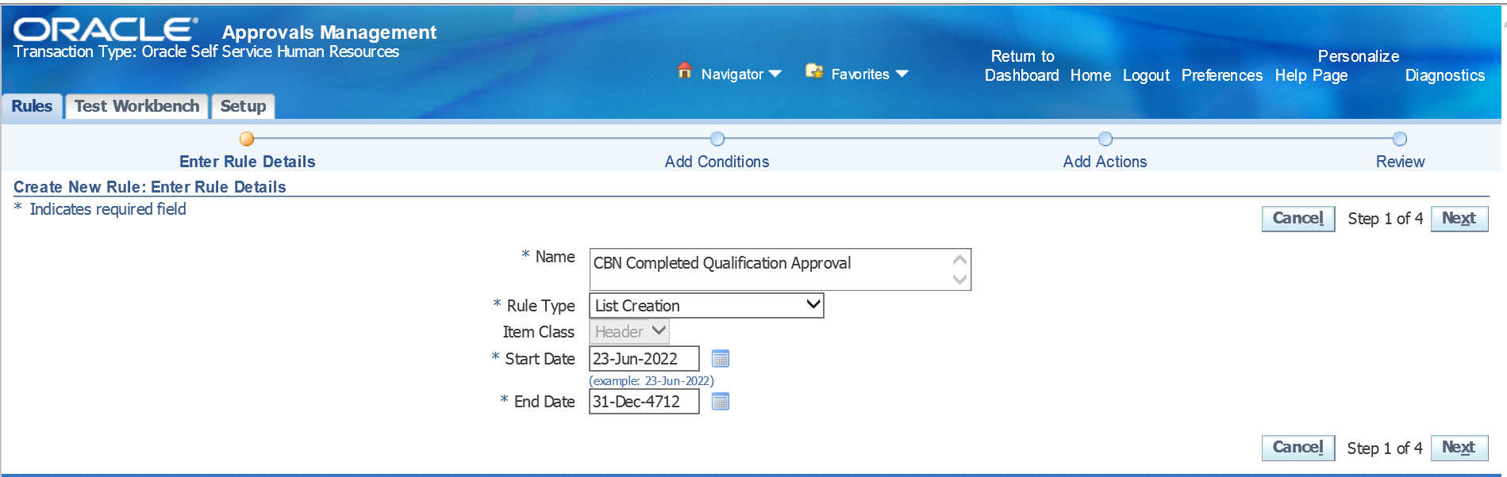

* Click on **Next** to navigate to **Add Condition** button to add conditions to the rules created

